***CAR RECOMMENDATION SYSTEM***

REPORT BY

**VIPUL PAL,SUMIT SINGH,HARSH PANDEY**

section*-*K19QK-G-1

*Roll Numbers:*

**04,05,15**



**Department of Intelligent Systems,**

**School of Computer Science Engineering,**

**Lovely Professional University, Jalandhar**

**November, 2020**

**Student Declaration**

This is to declare that this report has been written by us. No part of the report is copied from other sources. All information included from other sources has been duly acknowledged. We aver that if any part of the report is found to be copied, we are shall take full responsibility for it**.**

SIGNATURE



Name:

VIPUL PAL

SUMIT SHINGH

HARSH PANDEY

Roll Number:

RK19QKA04

RK19QKA05

RK19QKA15

**TABLE OF CONTENTS**

TITLE PAGE NO.

1.Background and objective of project assigned

1.1 INTRODUCTION 06

1.2 BACKGROUND 07

1.3 MOTIVATION 08

1.4 OUT-COME OF THE PROJECT 09

1.5 CONCREAT GOALS 10

1.6 APPLICABILITY 11

1.7 OBJECTIVE 12

2.DESCRIPTION OF PROJECT 13

3.TECHNOLOGIES AND FRAMEWORK USED 25

4. SWOT ANALYSIS 26

5. REFERNCES 27

**BONAFIDE CERTIFICATE**

Certified that this project report “CAR RECOMMENDATION SYSTEM” is the bonafide work of “MR.Vipul pal , Mr. Sumit singh and Mr. Harsh pandey” who carried out the project work under my supervision.

<<signature of the supervisor>>

(Due to Covid 19,(

signature is exempted )

Dr. Dhanpratap Singh

UMS ID: 25706

School Of Computer Science

and Engineering

**Background and Objectives**

**Chapter 1: INTRODUCTION**

* 1-We developed this project to book a car on rent at the fare charges.
* 2- In present system all booking work done manually and it takes very hard work to maintain the information of booking and cars.
* 3-It only makes the process more difficult and hard.
* 4-This aim of the project is to automate the work performed in the car rental management system like generating daily bookings, records of car or cab available for booking, record of routes available, rental charges for cars for every rout, store record of the customer.
* 5-Based on this information you can take decision regarding your business development.

***Subchapter 1.1: BACKGROUND***

**Car Recommender System**

I. Domain

Recommend top cars based on customer ratings, prices consiting of Rental fee, MSPR, Factory Invoice and Market price, car type and customer's behaviours from Edmunds.com

II. Purpose

Provide users with some knowledge on current car trends and purchasing ideas for

new and used cars.

III. Recommendation Context

The system targets users who wants to search for cars, looks at cool car images or watches

car videos.

IV. Source

1. Edmunds.com car information with images and customer ratings.

2. User Click's History

Additional information for application robustness:

1. Hotwire.com car rental availability based on recommended car details.

2. YouTube video links for recommended cars

V. Personalization

User Location through browser Geolocation (if supported by browser)

Current activity through clicks and search criteria, which can be tracked by Browser cookies

or IP Address.

VI. Interface

Input:

Search criteria (car make/model/year)

Output:

Car Recommendation with rental availability (Hotwire) and video links (YouTube)

Car recommendation as the same types watched which is to maximize benefits for customers.

**Subchapter 1.3 MOTIVATIONS**

The purpose of developing car recommendation system Very helpful for our life. Because how to shop a new car and our dream car we are know by this project. Very information know about car.

Meanwhile the clearance of issues and teaching of some beneficial elements was helped by our INT216 professor Mr. Dhanpratap Singh, and is taken in most respectful consideration. With the kind assemblage of the team members and some web tools for reaching the ultimate necessities we can entitle ourselves as very motivated to help bring better options to the community

## what are the benefits of a car recommendation system

A recommendation engine has a lot of benefits: it can significantly **boost revenues**, conversions, click-through rates ([CTRs](https://co-libry.com/glossary-terms/ctr/)), and more. Usually, it has a **positive effect** on the user experience, thus translating to higher customer satisfaction and retention

**Subchapter 1.4: OUT-COME OF THE PROJECT**

The out-come of the project is described as the system will be user friendly and will make simple operations which are done mostly manually could have a mode of getting the task done with a program, needing simple details filling and getting the results on a touch of a requirement. Later-onwards the project can be modified to be full-time online operation. Also, we as a team came to gain more knowledge into this field and realized how easy and necessary it is to provide our environment with

**Subchapter 1.5: CONCREATE GOALS**

Techniques suitable for making a **recommender system** robust against attacks ... main **goal** is not much to present a self-contained comprehensive introduction or ... **car** RS, a user, who has already bought her new **car** is aware that the rating en ... new **concrete** challenges and there is a real risk of stagnation

Car dataset contains information about the different types of cars, brands and other associated parameters. Data regarding brands and car details were collected from different authentic websites like cardekho, cartrade, carwala and official websites of that particular car model. Recent car models available in the market till Jul y 2017 including 40 brands and 224 car types are used in this research work. The attributes of the following categories like ENGINE & TRANSMISSION, CAPACITY.

**Subchapter 1.6: APPLICABILITY**

The design of feedback based collaborative filtering recommendation algorithm is discussed in [1]. This feedback component is of two levels external and internal. External feedback is to collect information from open platforms like automobile websites, social media etc. and internal feedback is to collect information from users who got recommendations. Extraction of various comments from the feedback added with recommender algorithm makes a hybrid model. There are limitations for this as the feedback component contains spam comments. In [2], dynamic recommendation algorithms for news domain are elaborated. In news domain, user profile will not be available and recommending news articles for the users by using dynamic algorithms becomes difficult. The top k ranked automobiles recommendations for a user is discussed in [3]. In [4], item-based collaborative filtering technique in a web based recommendation system has generated better recommendations. This model works with the combination of item-based collaborative fitter and k-nearest neighbour technique. In [5], the design of web based recommender system using clustering algorithm and genetic algorithm is discussed. Route recommender system [6] for vehicle

**Subchapter 1.7: OBJECTIVES**

As the global market rises and the demand of new brands on Indian economy leads to arrival of new models. All outside car manufacturers see Indian market as their place to grow in their share on global car economy. As world moves to the peak of a new era, recommendation become an unavoidable fact. Almost all the technical and non-technical things in today’s world wave hands to recommendation. The main fact that the recommendations got deeply rooted in new technology is due to its accuracy, precision and reliability. Recommendation gives a personalized choice to user’s requirements. In the proposed approach, the hybrid algorithm, which is the combination of user-to-user and item to item based collaborative filtering recommendation algorithm is efficient in suggesting recommendations.

**Chapter 2: DESCRIPTION OF PROJECT**

**2.1 – Car Recommendation system**

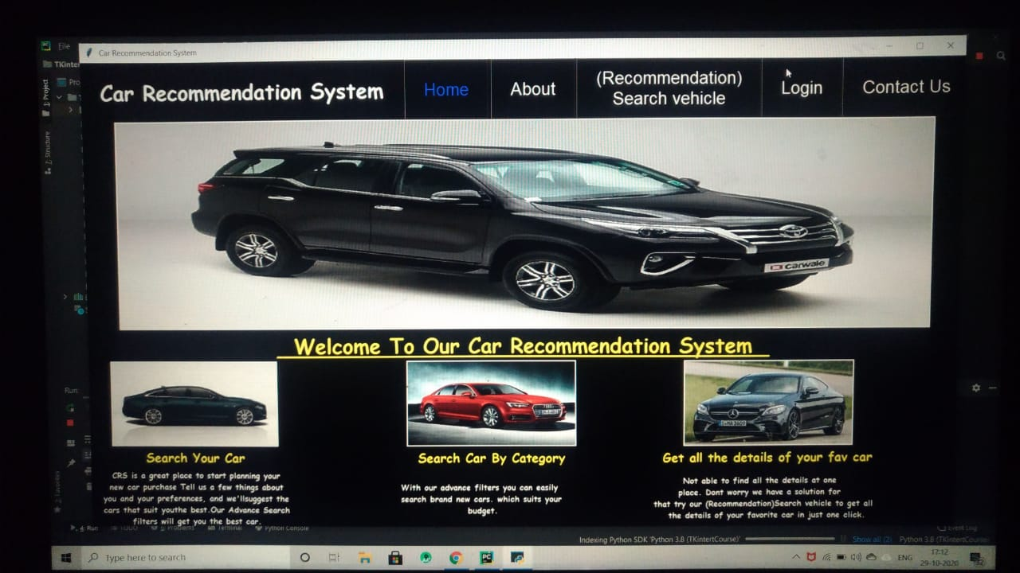

**2.2—About us page**

* About us page give information what is this project and why we chose this project in python subject.
* In website given the admin information .
* About us page introduced the website admin.

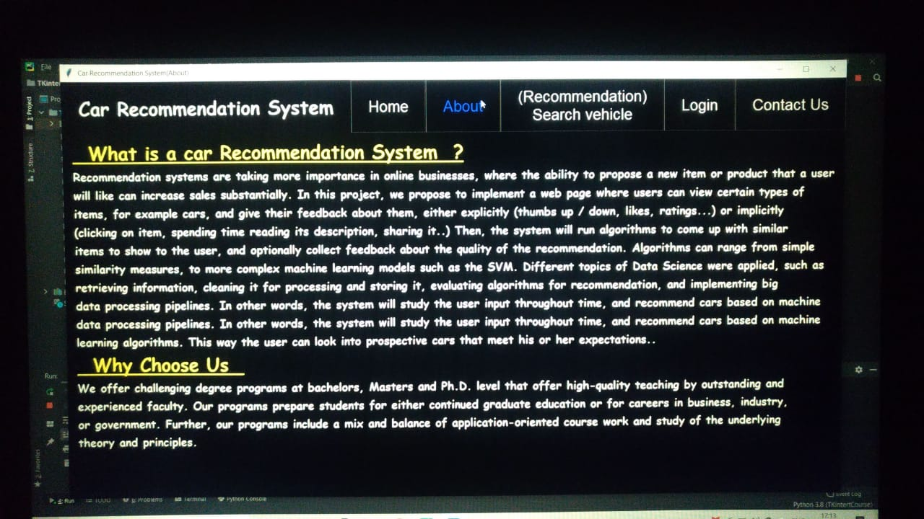

**2.3- User login**

* First fill email id and password then enter in this system.
* Important both email and password for enter this system.
* Every network user can have their own username and password to log in to the interface

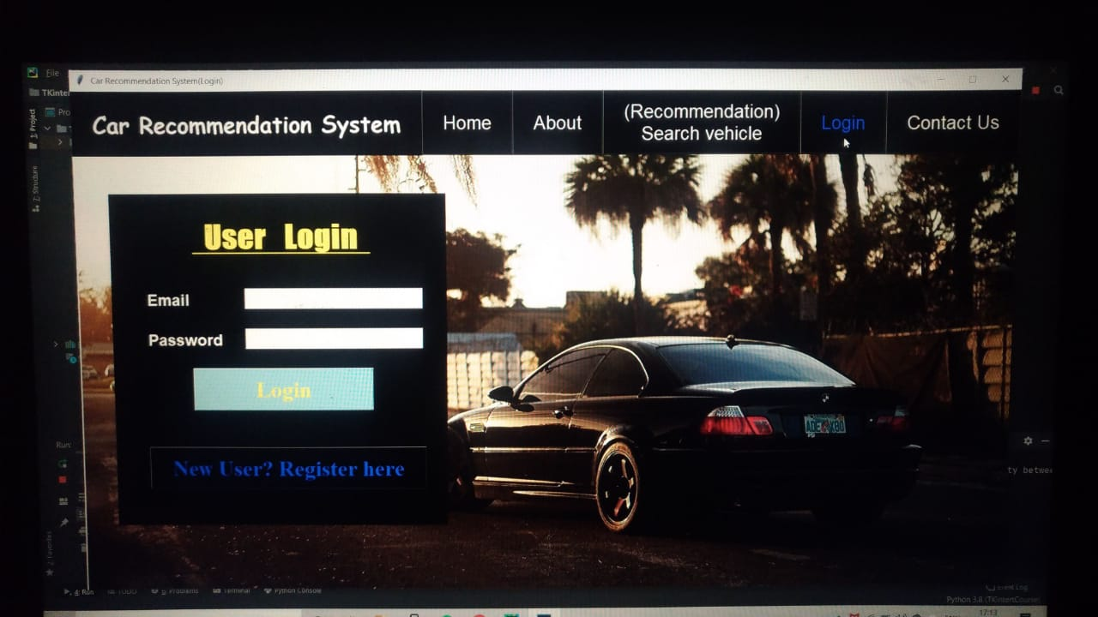

**2.4—user account**

* A user account allows or does not allow a user to connect to a network, another computer, or other shares.
* . Any network that has multiple users requires user accounts.

 A good example of a user account is an Internet or your e-mail account.

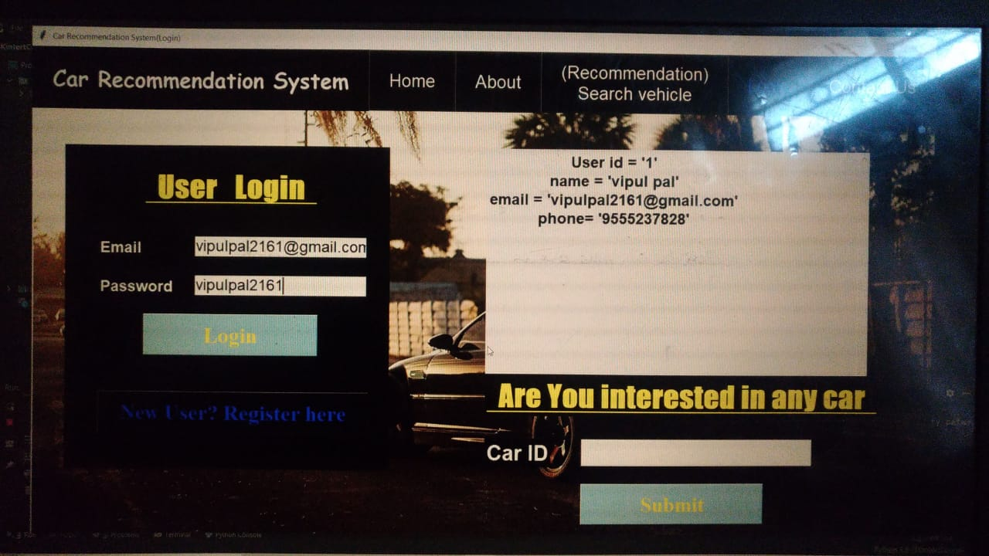

**2.5--** **User registration**

* User Registration plugin provides you with an easy way to create frontend user registration form and login form.
* The plugin is lightweight, extendible, and can be used to create any type of registration form.

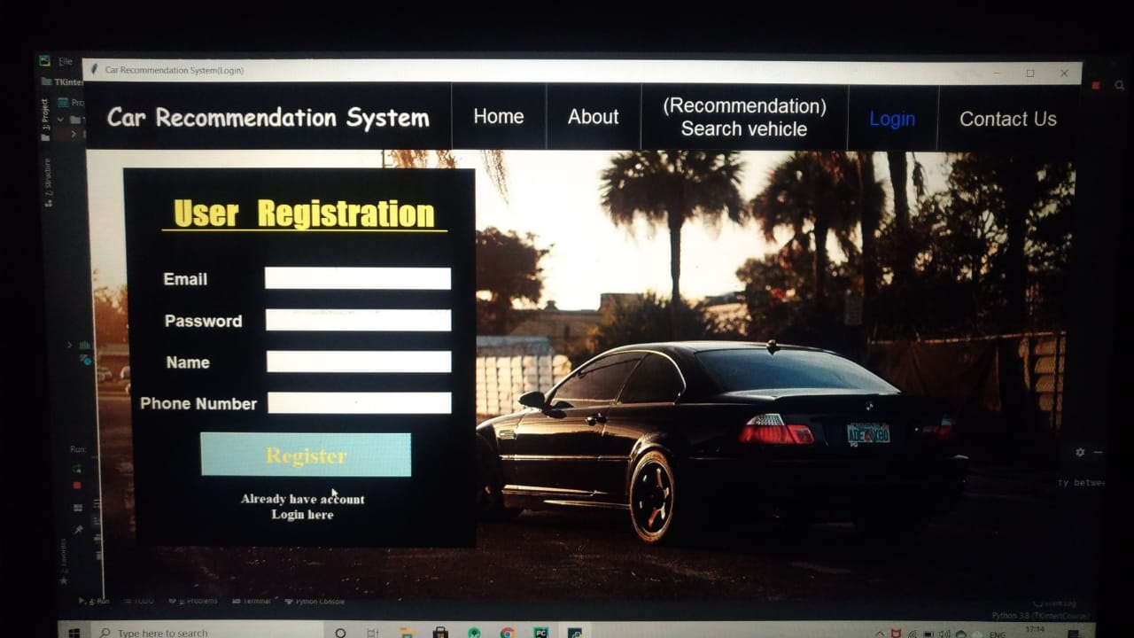

**2.6--** **Search vehicle**

* Search box in write any car name.
* car details are visible front of you.
* You need the car number plate details to get the required information.
* Visit the official website of [VAHAN](https://vahan.nic.in/nrservices/faces/user/login.xhtml) and click on 'Know Your Vehicle Details' and enter the required details to get your car registration certificate details.

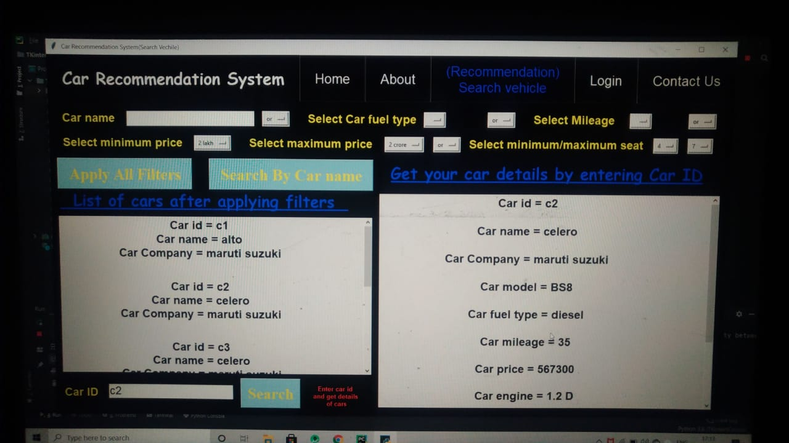

**2.7--** **Contact us page**

* For contact us in three option are required email, username ,phone no ,description.
* Description in describe his comments(talk).

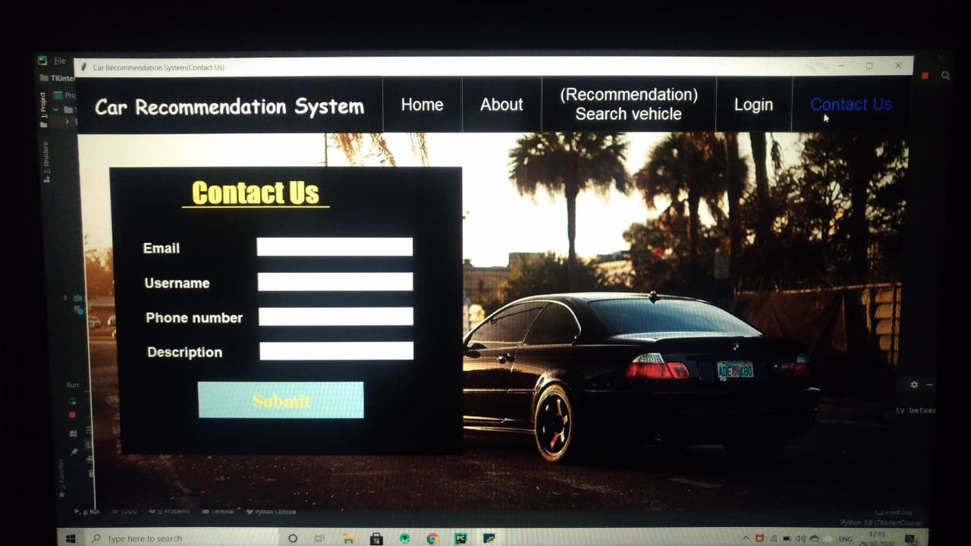

**2.7-- Admin(car portion)**

* Admin control the car details modal car id, car name, car mileage, car price car company , car engine , car transmission , car capacity and car coler , also important talk about car related.
* 1-There are three properties in the Car Control section named add car, update car, delete car which are controlled by the administrator.
* 2-After logging the car option is clicked and then it will be possible to see the list of car information.
* 3-After logging the car option is clicked and then it will be possible to see the list of car information**.**

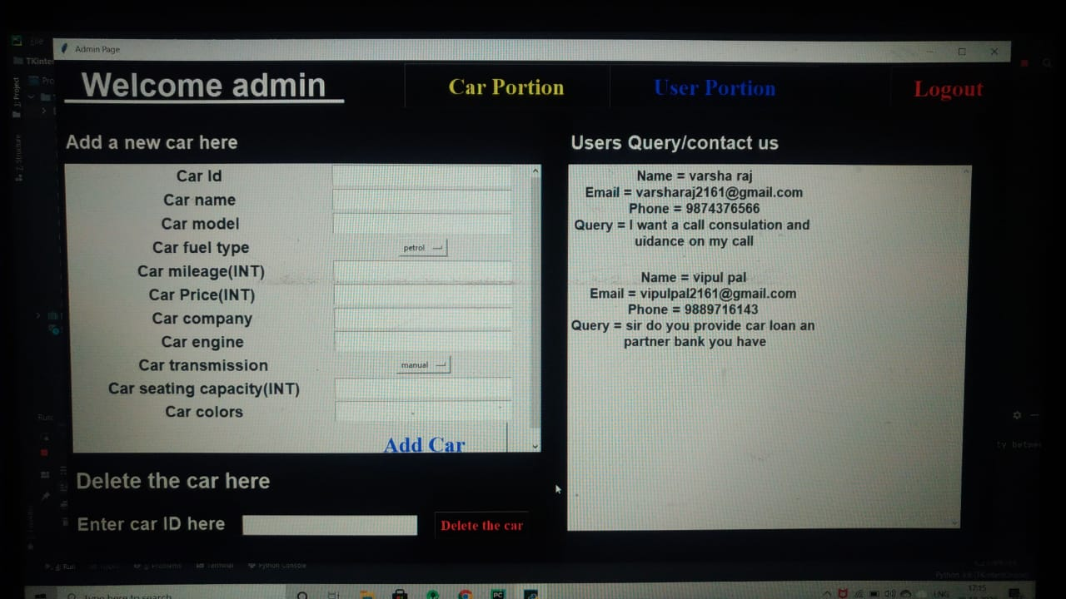

* 4-There are two links named edit and delete options.
* 5-By clicking on those links we can update the car information page.
* To complete this task the user must be admin

**2.8--** **Admin(user portion)**

* Admin (user option) handle the Handles many other users.
* When connected to the background management platform that is to URL then the administrator login page will be displayed and will ask the username and password, according to the administrator views on the management page.

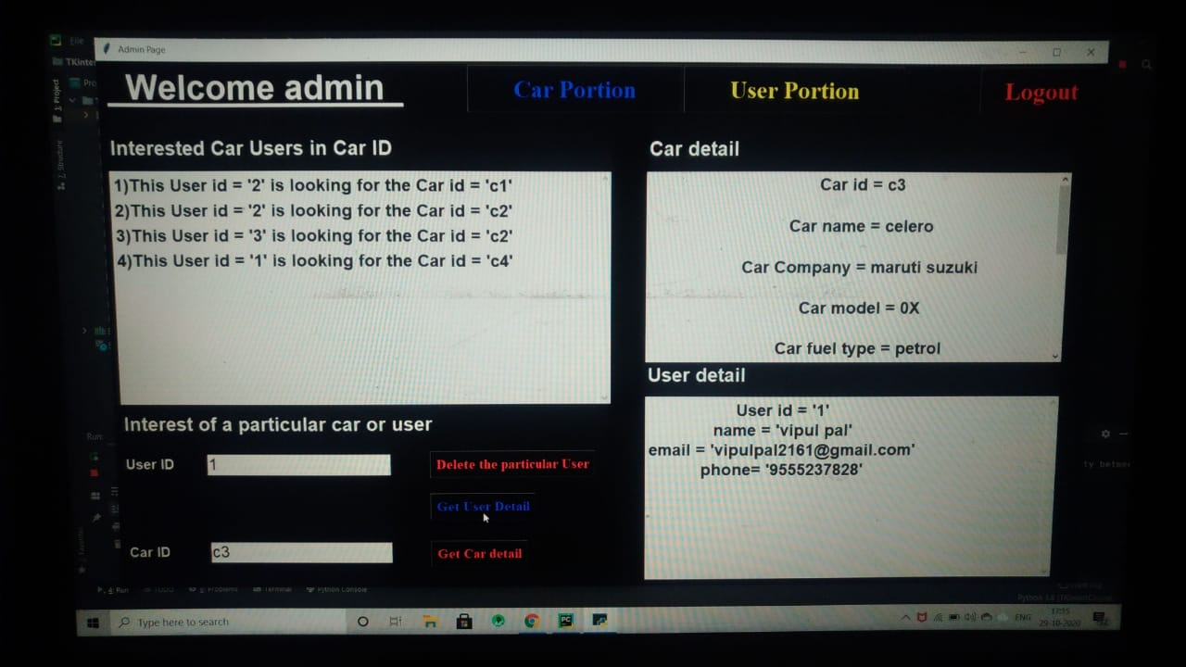

**2.9 –Admin (car control)**

* There are two properties in the admin control named Username and Password.
* When the management option is clicked then you will be possible to see the admin interface.
* In the admin control section the administrator plays an important role in the Online Car Selling Application for example by adding a car, deleting a customer, deleting a car and updating information.

**Chapter-3**

**TECHNOLOGIES AND FRAMEWORK USED**

**3.1** This project is made Python. Moreover to make the project system more interactive and user friendly Tkinter GUI and SQLite3 are used.

Tkinter is Python's de-facto standard GUI (Graphical User Interface) package. It is a thin object-oriented layer on top of Tcl/Tk. Tkinter is not the only GuiProgramming toolkit for Python. It is however the most commonly used one. Tkinter is the standard GUI library for Python. Python when combined with Tkinter provides a fast and easy way to create GUI applications. Tkinter provides a powerful object-oriented interface to the Tk GUI toolkit. Import the Tkinter module.

**Chapter-4 swot analysis**

**Strengths.**

The forecast reliability analysis subsystem is designed for collection of the statistical data on compliance of recommended goods with the actual choice of a buyer. The most widely spread metrics for assessing the quality of recommender systems include precision and recall of the forecast. Precision is determined as a share of objects interesting for a buyer among the offered recommendations. Recall is determined as a share of recommended objects among all objects interesting for a buyer

**Weekness**

• Token numbers must be conserved for referential usage

• Updating of the function’s source code might be needed if pricing or taxes changes.

• Errors in program of a single frame can lead to disruptions in other frames.

**Chapter-5 REFERENCES**

Here are some honorable references used for completion of the project:

• Google

• Wikipedia

• Introduction to programming using python by Y. Daniel Liang

• Python Programming: Using problem solving approach by Reema

…………………………………..END THE REPORT……………………………………………